Renju lesson on May 17, 2001

Hello all! Welcome to Online Renju Class. Happy anniversary to everyone!! Online Renju Class is 1 year old now. ^_^

We will have shorter lesson than usually, and after the lesson we will have the big celebration game teacher versus students.
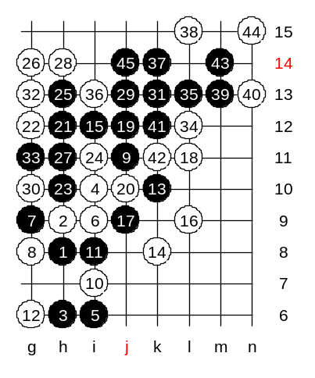
Can you guess which 14th move I am going to teach you today? 14-k8. :) Black wins here quite easily.
However, as you saw from last world championship game, even the A-final players do not always know win here.
Move 15-i12 is the correct beginning.
I am sure black has many ways to win here. We just try one of the examples here.

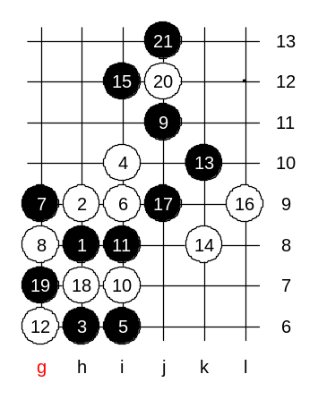
Another 18th move.
I have a question to you. After 20th move, how do you usually attach in such positions as black?
In my mind, the 21-j13 is the strongest development here. It creates lots of powerful connections.
Remember, it is not important to have many lines. As you see, the move 21 just created one pair. But it is important to create lots of powerful connections.
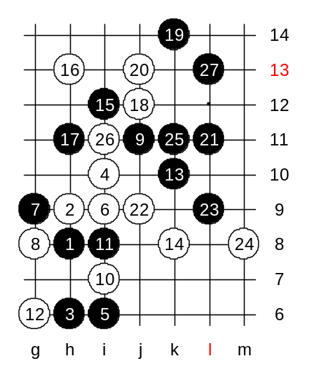
We do not need to check any 22nd move here because black wins here are quite easy.

We change the 16th move now. If black plays 17-j9 now, then most probably black will fail the attack because of 18-L11.
Black uses strong 17-h11 instead. Now we try first defense move 18-j12. How can black attack so that white h7 cannot bother us?
Move k14 is the key. Now white h7 defense becomes useless.
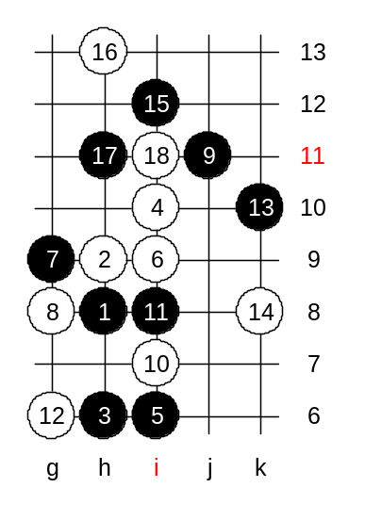

Another 18th move.
This is the medium level homework.
Please find the black win.

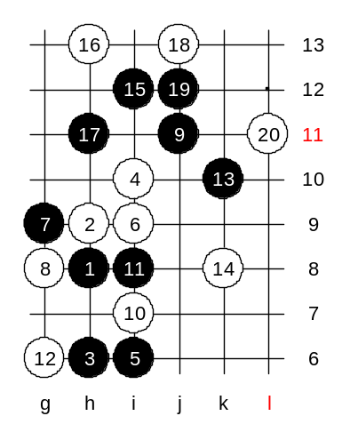

Another 18th move.
This is the strongest defense. Black win here is not easy.
It seems that only 19-j12 gives black win here. Move 20-L11 is the best resistance, but black still wins.
How?
This is your advanced level homework.
Please find the black win.

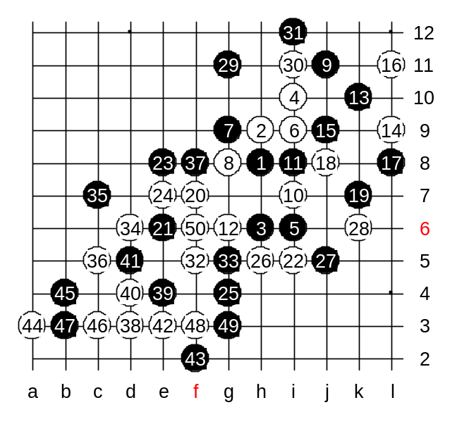
Now we will begin the game teacher versus all students. I will give you the black advantage opening, and your teamwork purpose is to make your advantage become victory. I wish you luck! We also need someone who will count students votes for each move.
Black: Students
White: Teacher
Move e8 was perhaps weak.
Move 31 was a big mistake. Black did not have VCT in upper side and with move 32 white began the winning attack.

